Create a simple cloud software application for Flight Reservation System using any Cloud Service Provider to demonstrate SaaS.
AIM
To design and deploy a simple Flight Reservation System using Zoho Creator as a cloud service provider and demonstrate Software as a Service (SaaS), where users can access the application through a web browser without installing any software.
PROCEDURE
- Login to Zoho Creator using a valid Zoho account.
- Create a new application named Flight Reservation System.
- Create a Passenger Details Form with fields such as Name, Age, Gender, Mobile Number, and Email ID.
- Create a Journey Information Form with fields such as Source City, Destination City, Date of Journey, Return Date, Type of Journey, and Number of Passengers.
- Create a Flight Details Form with fields such as Airline Name, Flight Number, Flight Type, Class of Travel, and Travel Duration.
- Create a Payment Details Form to store payment mode and transaction status.
- Link all forms within the application to maintain reservation data.
- Configure access permissions to allow users to submit flight booking details online.
- Publish the application to the cloud and access it using a web browser.
- Test the application by entering sample flight reservation data.
Output
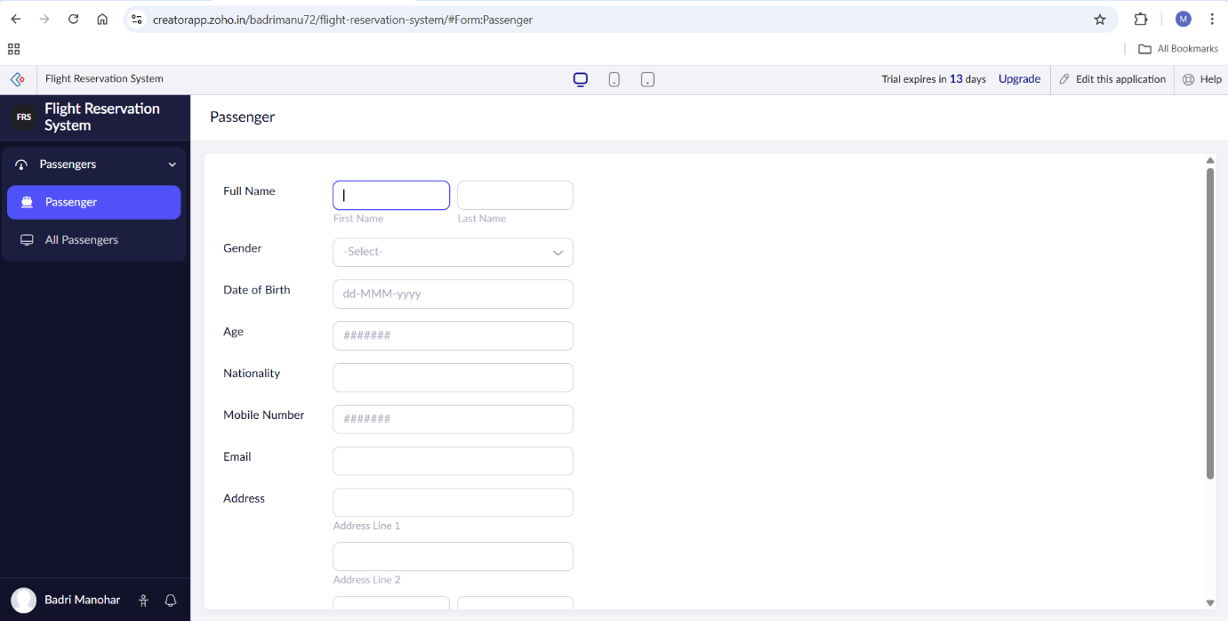
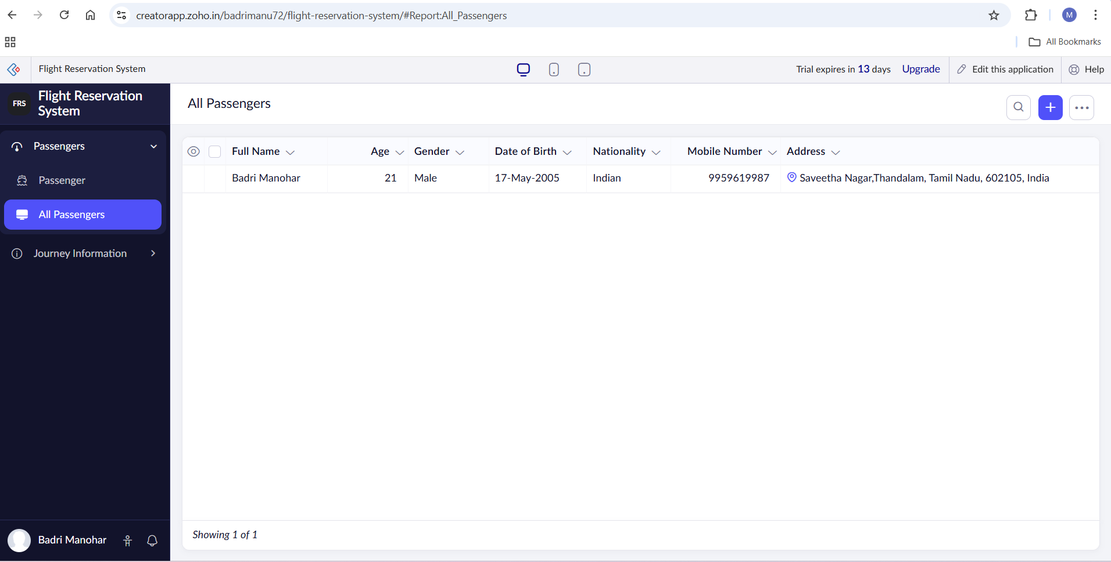
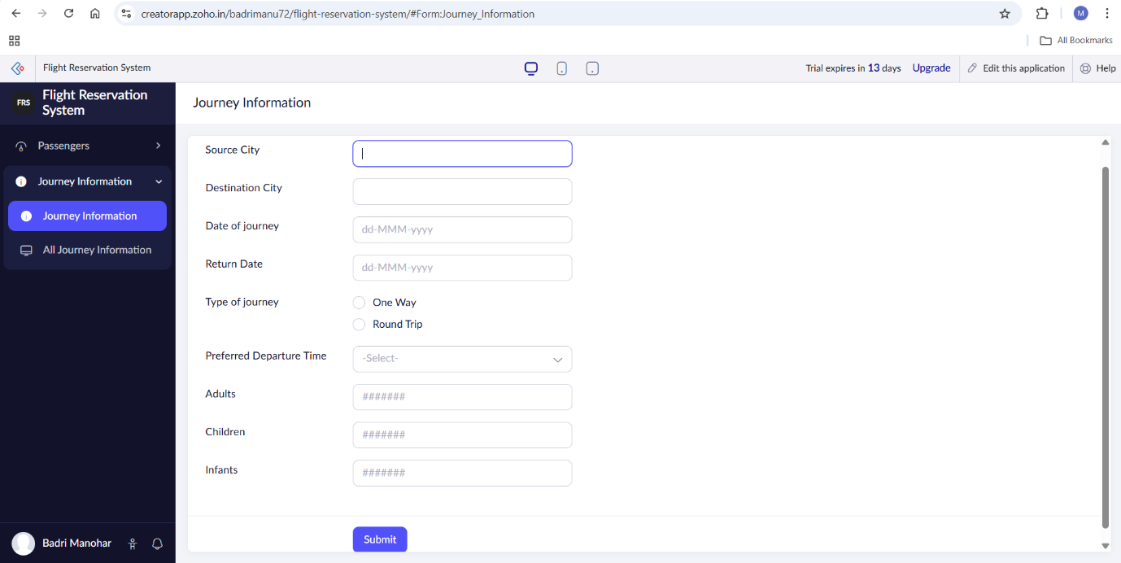
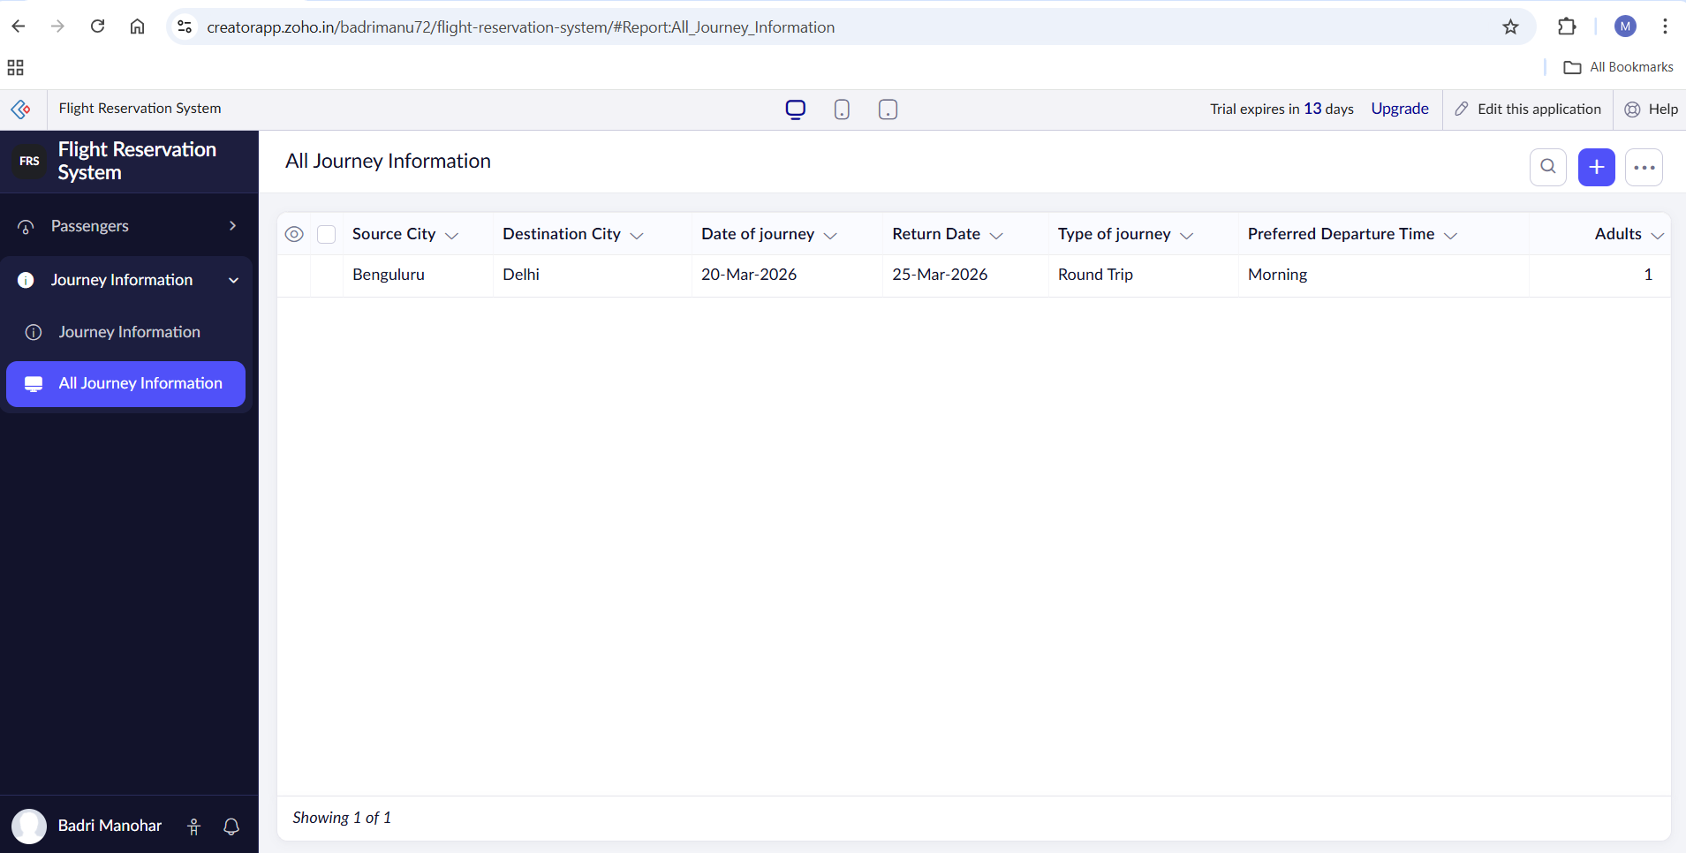
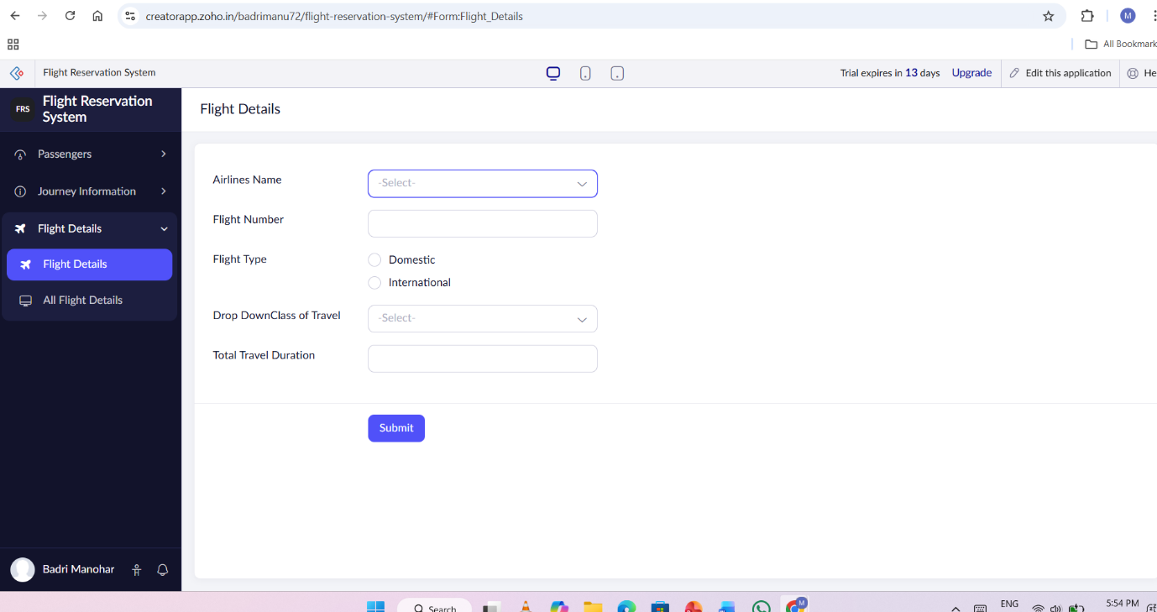
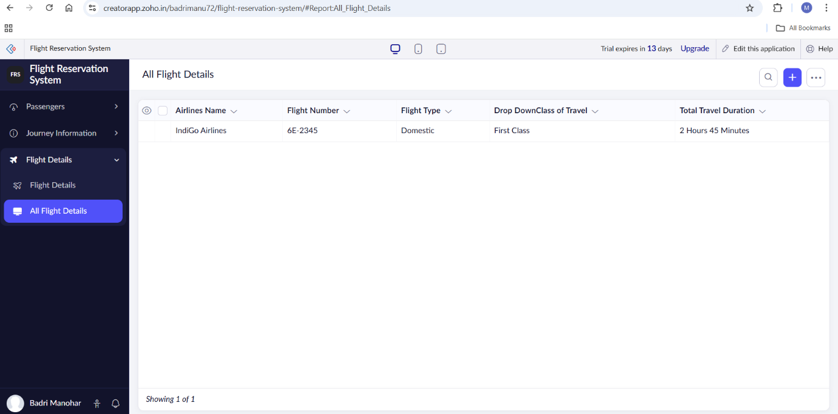

RESULT
A simple Flight Reservation System was successfully created and deployed using Zoho Creator as a SaaS application. The system allows users to enter passenger, journey, flight, and payment details through a web interface. The application is accessible from anywhere via the internet without installing any software, thereby demonstrating the Software as a Service (SaaS) model.

